

Name : Y.Manoj kumar Course name : 5Gand6G Communicaton Registration num:1912260567 Course code : ECA5610
Experiment Number:
Analysis of 5G NR Frame Structure and Subcarrier Spacing
Aim: To analyze the 5G NR frame structure by studying subcarrier spacing, slot duration, OFDM symbols and simplified downlink/uplink resource assignments using MATLAB, and to relate the radio resources to gNodeB functions and RRC operation.
Objectives

• To generate or inspect a simplified 5G NR resource grid.
• To compare selected subcarrier spacings and their effect on symbol or slot duration.
• To identify basic downlink and uplink resource assignments in the model.
• To relate the radio resources to gNodeB functions, RAN organization and RRC’s role
Software Required
• MATLAB
Theory
5G NR uses flexible numerology. For the standard subcarrier-spacing sequence used in the master record, 15, 30, 60, 120 and 240 kHz correspond to numerology indices 0 through 4. With a normal cyclic prefix, a slot contains 14 OFDM symbols. Increasing subcarrier spacing reduces slot duration, enabling flexible latency characteristics.The gNodeB is responsible for radio access functions and scheduling, while RRC performs control and configuration functions such as radio-resource configuration and connection management.

Objective – 1: Generate / Inspect a Simplified 5G NR Resource Grid
Procedure
1.Define the number of subcarriers and OFDM symbols.
2. Create a simplified matrix representing the resource grid.
3. Assign sample downlink and uplink resources.
4. Display the resource allocation using an image representation.
5. Interpret the time-frequency organization.
Program:

clc;
clear;
close all;

% Analysis of 5G NR Frame Structure and Subcarrier Spacing

% Subcarrier spacing values in kHz
SCS = [15 30 60 120];

% Corresponding slot duration in milliseconds
SlotDuration = 1 ./ (SCS / 15);

% Display results
fprintf('5G NR Subcarrier Spacing Analysis\n');
fprintf('---------------------------------\n');
fprintf('SCS (kHz)\tSlot Duration (ms)\n');

for i = 1:length(SCS)
fprintf('%d\t\t%.3f\n', SCS(i), SlotDuration(i));
end

% Plot 1: Subcarrier spacing vs slot duration
figure;
plot(SCS, SlotDuration, 'o-', ...
'LineWidth', 2, 'MarkerSize', 8);
grid on;
xlabel('Subcarrier Spacing (kHz)');
ylabel('Slot Duration (ms)');
title('5G NR: Subcarrier Spacing vs Slot Duration');

% Plot 2: Number of slots per 1 ms subframe
SlotsPerSubframe = SCS / 15;

figure;
bar(SCS, SlotsPerSubframe);
grid on;
xlabel('Subcarrier Spacing (kHz)');
ylabel('Slots per 1 ms Subframe');
title('5G NR Slot Structure');

% Plot 3: Simplified 5G NR frame structure
figure;
hold on;

% One radio frame = 10 ms
% One subframe = 1 ms
for i = 0:9
rectangle('Position', [i, 0, 1, 1], ...
'EdgeColor', 'k', 'LineWidth', 1.5);
text(i + 0.5, 0.5, sprintf('%d', i), ...
'HorizontalAlignment', 'center');
end

xlim([0 10]);
ylim([0 1]);
yticks([]);
xlabel('Time (ms)');
title('5G NR Radio Frame: 10 Subframes');
grid on;
hold off;

disp('Analysis completed successfully.'); 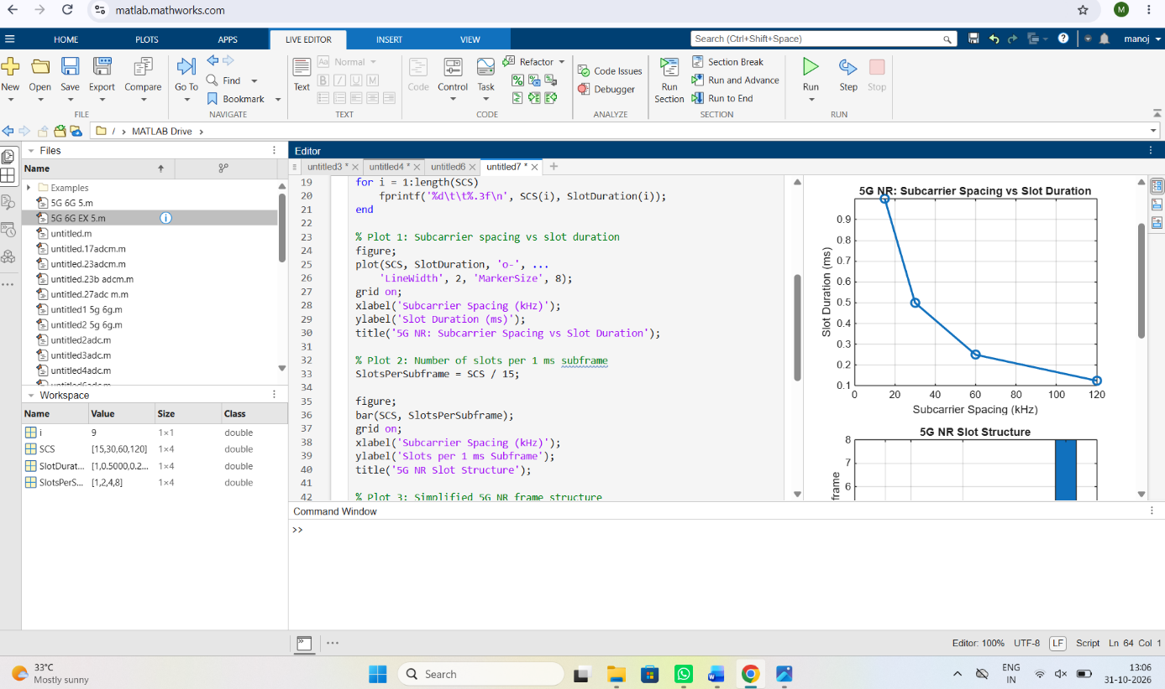
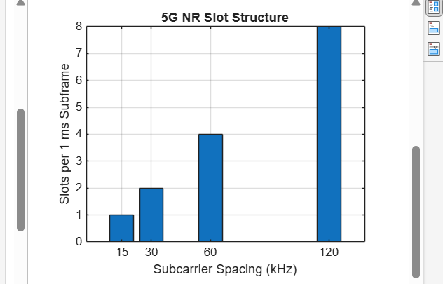

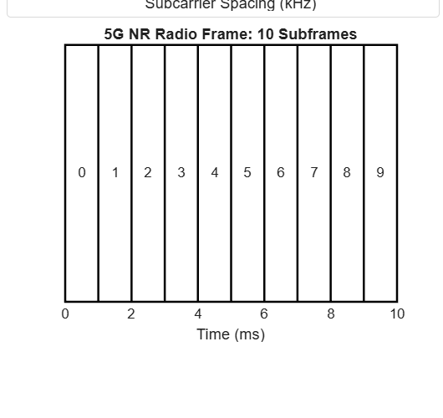

Result
1. A simplified 5G NR resource grid was generated and inspected.
2. The effect of different SCS values on slot duration was analyzed.
3. Basic downlink and uplink resource assignments were represented.
4. The relationship among NR radio resources, gNodeB operation, RAN organization and RRC was explained.
Discussion
The experiment demonstrates the flexible numerology of 5G NR. The master record identifies 15, 30, 60, 120 and 240 kHz SCS values and shows that slot duration decreases as SCS increases, while a normal cyclic-prefix slot contains 14 OFDM symbols. This flexibility supports different deployment and latency requirements. The resource-grid exercise connects these physical-layer resources to practical RAN functions such as scheduling and radioresource control.
Practical Question – 1
Using MATLAB, analyze the 5G NR frame structure for different subcarrier spacings and create a simplified resource grid showing basic downlink and uplink allocation.
• To generate or inspect a simplified 5G NR resource grid.
• To compare selected SCS values and slot durations.
• To identify simplified downlink and uplink resource assignments.
• To relate radio resources to gNodeB and RRC functions.

